## OPTIONAL: Watch the screencast before class!

Open the [screencast](http://youtu.be/gPXZzR3_Kb4) and follow along with the lecture. Be sure to try all the examples you see in the lecture on Netbeans **don’t just sit and watch the show!**

NOTE: the screencast uses MAMP which is a variant of XAMPP. You do not need to install MAMP. Everything is about the same except the name and location of htdocs. It also uses both JS and JAVASCRIPT. The concepts are the same.

#### Exercise 1: Data types and output (>5 min DNF)

For each kind of data presented, state what data type would be useful to represent it, make an example of the data and output it as indicated. Note that in the console everything will automatically be put into console.log() to output so you can just type the expression to output.

<your full name> directly in the JS console: string

<number of months since your last birthday> in JS appended to the end of the current document: number

Hint: You will unlikely be able to this now because you need to create a document object to append. You cannot just append text to a document.

<approximate age in fractions of year> in JS inside a div with id “ageDiv”: boolean

<true or false - you are over 21 years old?> directly in the JS console: boolean

#### Exercise 2: Assigning variables with expressions (>5 min DNF)

a) Write Javascript statements that assign to a variable the number of kids you might want (or have already) and displays the value of this variable (e.g. "I would like to have " + var + " kids"). Use an appropriate, meaningful variable name (not var as it is now!).

b) Repeat the above except multiply the number of kids by your age (yes, this may be a large number of kids!).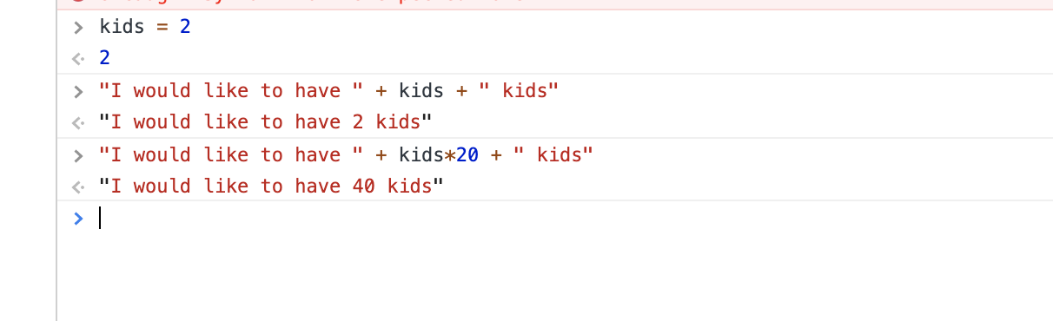

c) Now multiply the above by the variable stupid. What result did you get and why is it likely not what is desired? Did you get a warning message? If so, explain why. If you did not, explain what warning message you should get here.

We got a warning message because we didn’t define “stupid” in this situation. If we had defined it then we wouldn’t get the warning message.

#### Exercise 3: String expressions (>5 min DNF)

a) Write JS statements to create a string variable containing your first name. Use an appropriate, meaningful variable name (e.g myGloriousFirstName).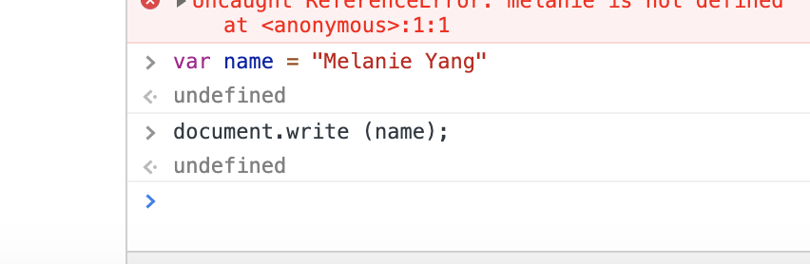

b) Now create variables for your last name and middle name. If you don’t have a middle name, use “Rick” (it is, after all, a lvarovely name).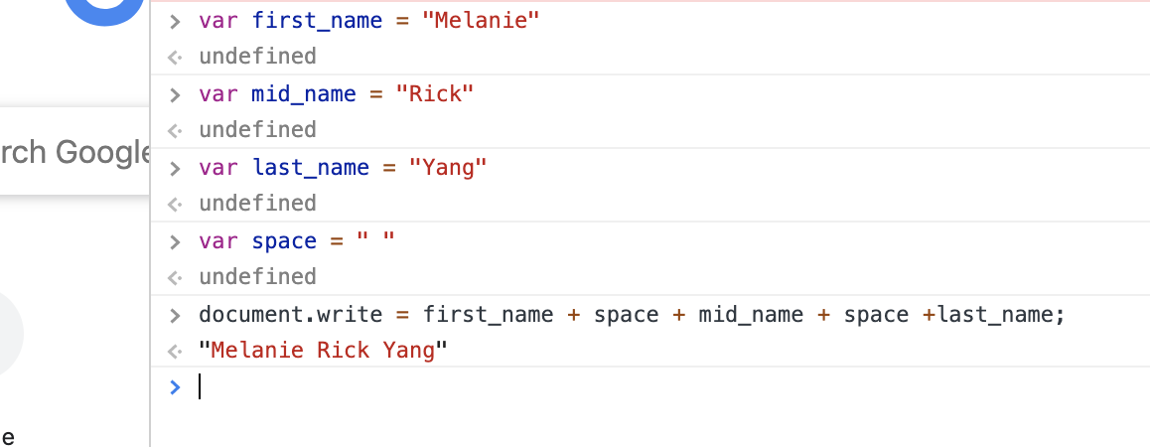

c) Now create a single string variable that puts all three parts of your name together, via concatenation, an HTML line break, then a your initials taken as the first characters from the first and last name variables. Don’t forget spaces between your names and the periods after each initial :)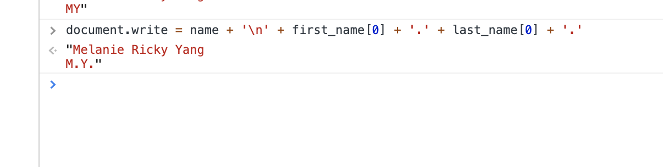

d) Now create a second string variable that puts all three parts of your name together, via concatenation, with an HTML line break between each of your names, where your first name is **Bold**, your middle name is in *Italics*, and your last name is in a VERY LARGE font.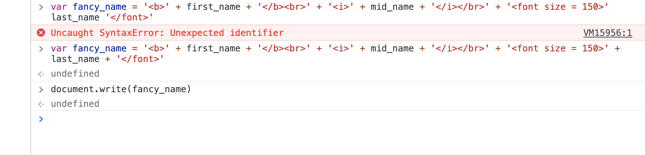

#### Exercise 4: Formatting floats (>5 min DNF)

Use number.toFixed() to output

The tax on <your name>’s bill is <4.13% * amount>

Only print 2 decimal points for the floating point value <0.0413 * amount> You may choose any amount between $1.00 and $500.00

